Coates, Wells Wintemute (1895-1958)

Michael Johnson, Northumbria University

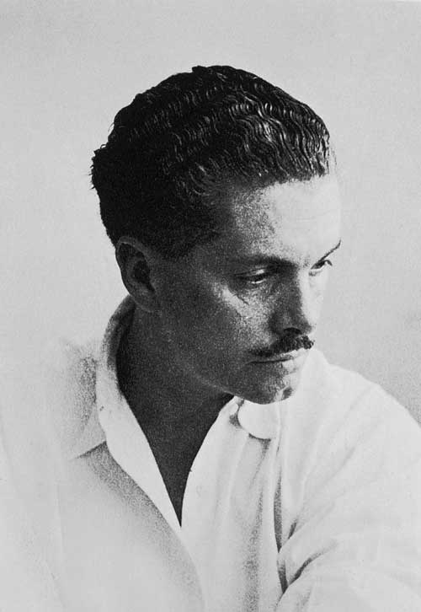

Wells Coates c.1925

http://www.studio-international.co.uk/studio-images/Lawn_road_flats/LAwn_road_2b.jpg

Wells Coates was a Canadian-born architect and industrial designer who became a pioneer of modernism in Britain. As a founder of the Isokon design company, he was instrumental in introducing the radical aesthetics of European modernism to a sceptical British public. His work as an industrial designer yielded a range of modern consumer products that helped to transform the British domestic interior. Among his major achievements was the design of Lawn Road Flats in London, one of the first mass-housing blocks in Britain and an icon of modernist architecture.
Coates was born in 1895 in Tokyo, Japan where his parents were Methodist missionaries. He was exposed to architecture from an early age by his mother, who had studied under proto-modernist architect Louis Sullivan, who is credited with inventing the skyscraper and coining the axiom ‘Form follows function’. However, Coates studied engineering at McGill University College of British Columbia in Vancouver, Canada (now the University of British Columbia) and obtained a PhD at London University for research on the diesel engine. He worked as a sub-editor for the Daily Express newspaper, with a particular focus on technology, but gravitated towards the design profession. With his engineering background, Coates was committed to functional design and economy of means, values which accorded with the principles of the emerging Modern Movement. Indeed, Coates admired the work of Le Corbusier and Charlotte Perriand, and embraced their utopian social ideals.
Coates’ first important commission involved redesigning a shop in Cambridge for Crysede silks (1928), for which he used standardised plywood fittings to create a strikingly modern interior. Cresta Silks, an offshoot of Crysede, commissioned him to design the interior of a new factory in Welwyn Garden City, as well as a series of shop fronts and interiors. Coates produced furniture to complement these interiors and cubic lettering for the exterior. He also invented the D-handle, an innovation that is still in use today.
The plywood manufacturer Jack Pritchard had been impressed by Coates’s innovative use of plywood in his designs for Cresta and Crysede. In 1931 Coates and Pritchard established Isokon, a design firm which aimed to create modernist architecture and furniture. Pritchard commissioned Coates to design a block of flats in Hampstead, London using Le Corbusier’s concept of the machine à habiter (machine for living). Lawn Road Flats (1934) was a four-storey apartment block made of reinforced concrete, with sculptural stairways and access galleries cantilevered out from the white expanse of the walls. Coates implemented his concept of the ‘minimum flat’, which united the influence of Japanese interiors with his belief that furniture should be an integral part of buildings. All essential elements were built-in: each flat included a sliding table, divan, light fittings, dressing table, electric cooker and fridge. Lawn Road Flats became a magnet for émigré modernists escaping oppression in Nazi Germany. The Bauhaus designers Walter Gropius, Marcel Breuer and László Moholy-Nagy all took up residence here, as did the crime novelist Agatha Christie.
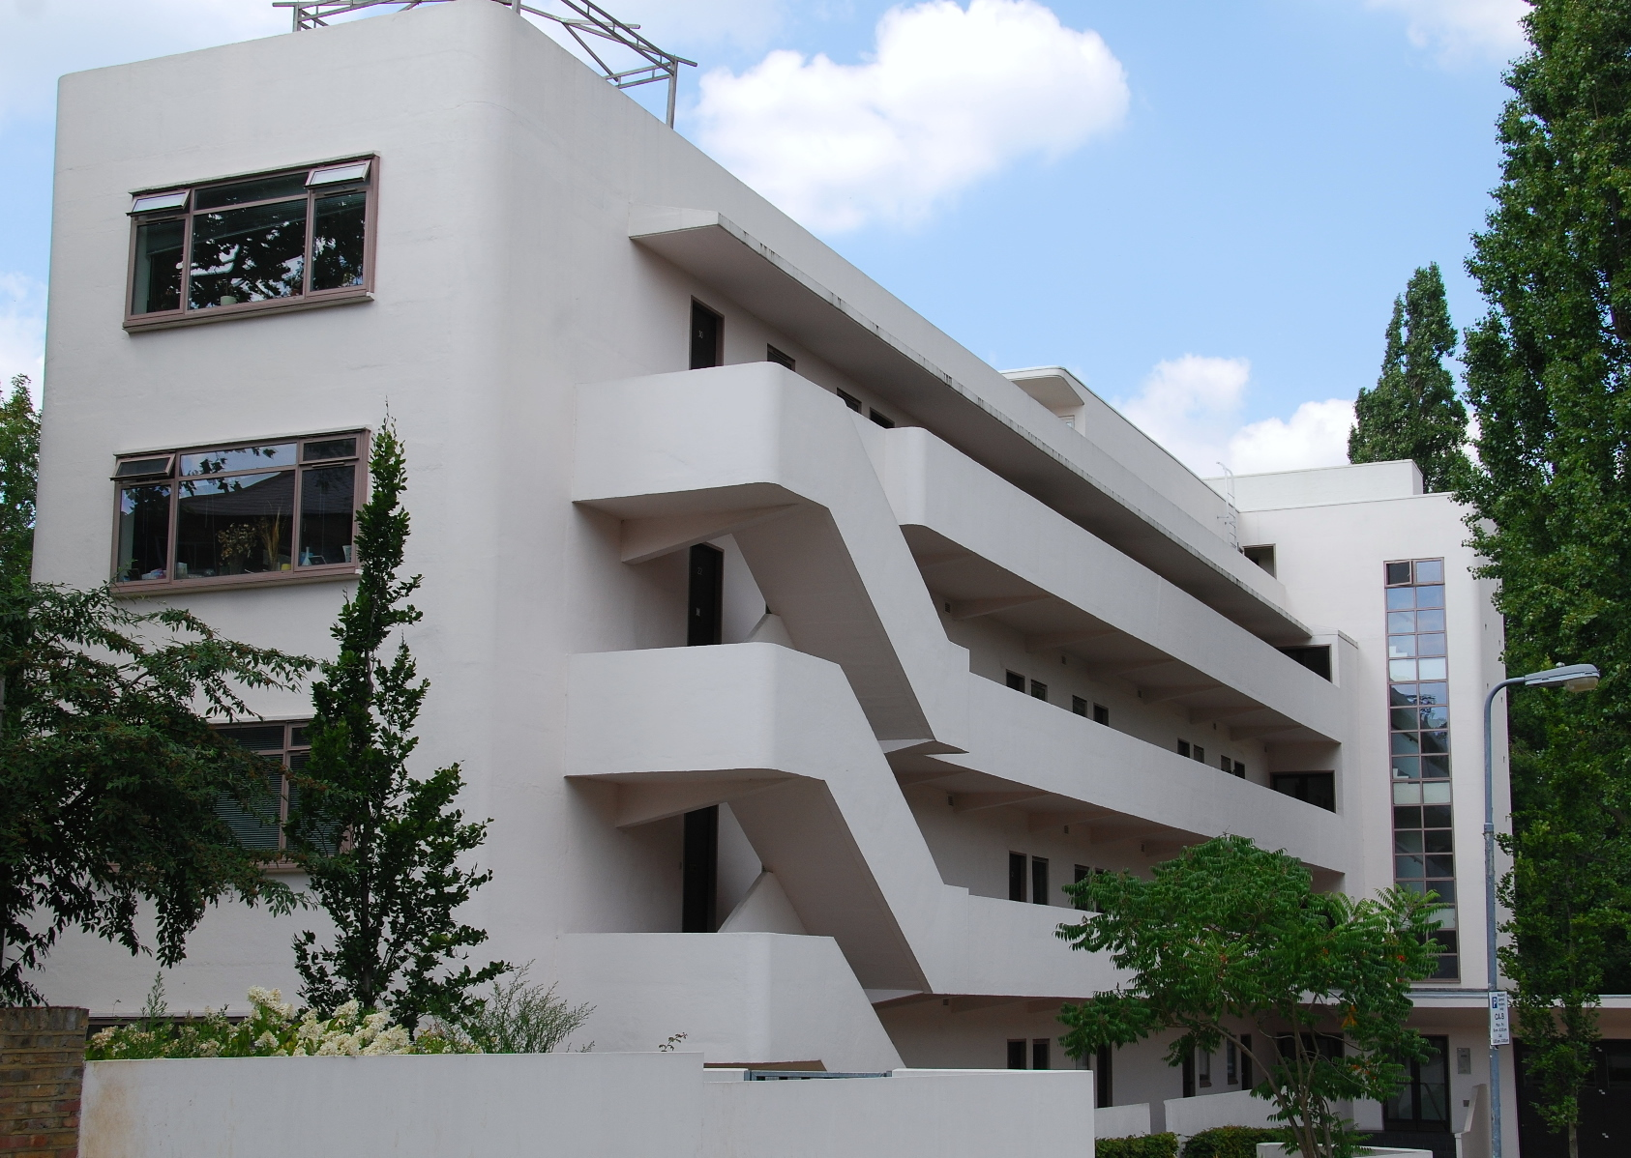
Lawn Road Flats, London (1934)
http://londonbytes.files.wordpress.com/2011/06/isokon1.jpg
In conservative 1930s Britain, modernism was viewed with suspicion by the general public and some sectors of the design establishment, but it was appreciated by a number of public and private bodies. One of the organisations that took up modernism with enthusiasm was the British Broadcasting Corporation (BBC), a technological broadcasting network with high social ideals. From 1930 Coates designed a series of studio interiors for the BBC, all based on minimalist aesthetics. He also designed a range of technical equipment, including an ingenious microphone that could be moved to any part of the studio while remaining perfectly balanced. One of his most productive working relationships was with the plastic moulding firm E.K. Cole and Son (known as Ekco), for whom he designed the AD-65 wireless radio (1932), which exploited the possibilities of Bakelite. In 1937 he designed the Thermovent electric fire for the company. With their geometric forms and sculptural casings, these products brought modern design and technology into the British home.
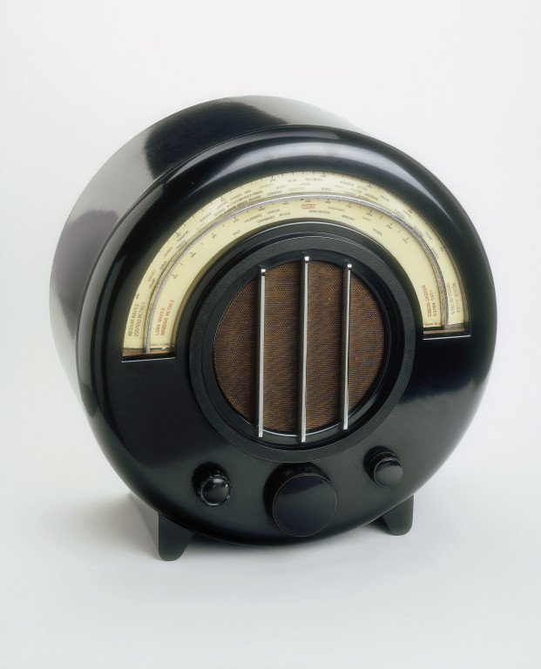

Ekco AD-65 Radio (1932)
http://media.vam.ac.uk/media/thira/collection_images/2006AT/2006AT8023.jpg
Coates was committed to the modernist ideal of social reform through design. In 1933 he co-founded the Modern Architecture Research Group (MARS), a British wing of the Congrès Internationaux d’Architecture Moderne (CIAM). This acted as a forum for debating the problems facing modern British architecture and brought Coates into contact with many eminent practitioners and theorists. Determined to bring the benefits of intelligent modern design to the masses, in 1934 he unveiled the first of several ‘Sunspan houses’ at the Daily Mail Ideal Home Exhibition in Olympia, London. Resembling the elemental villas of Le Corbusier, few of these houses were ever built, but they represented a humane form of modernism for middle class residents.
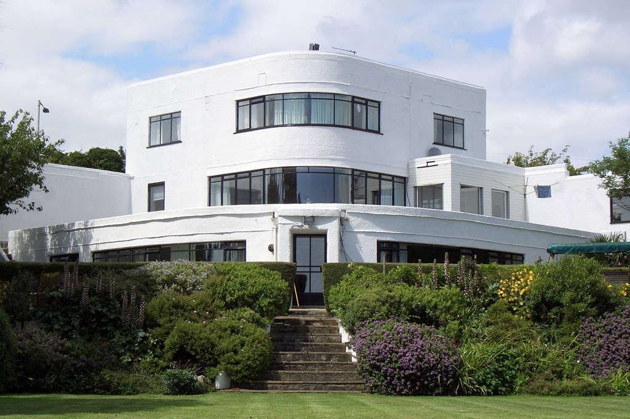
Sunspan House, Portsmouth (1934)
http://www.flickr.com/photos/7944912@N05/661450818/
Coates pursued his experiments with minimalist living by converting the top floor of 18 Yeoman’s Row in Knightsbridge, London into a studio flat for his own occupation (1935). This sparsely furnished apartment featured an open plan living room with high ceilings and bedrooms above the kitchen and bathroom, reached by ladders. One of the beds rested on a plinth of glass bricks which refracted light into the bathroom below. In place of sofas, Coates introduced tatami mats, again reflecting his early exposure to Japanese interiors.
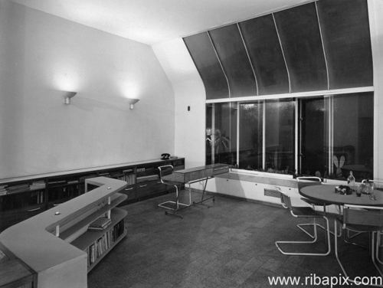
Wells Coates’s flat at 18 Yeoman’s Row, London (1935)
http://www.ribablogs.com/wp-content/uploads/2012/08/WellsCoates_RIBA72564_500px.jpg
A more communal vision of modern living was achieved with Embassy Court (1936), a block of flats in Brighton, on the south coast. This was a graceful multi-storeyed building, where ascending cantilevered balconies culminated in a penthouse suite, the first of its kind in Britain. Avoiding the monolithic quality associated with mass housing blocks, the building was skilfully articulated with horizontal decks and vertically-unified bay windows, as well as the ziggurat configuration of the upper floors.
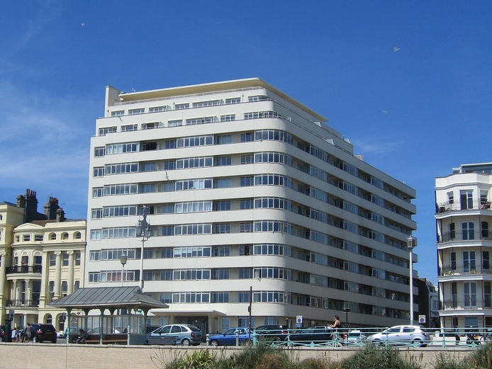
Embassy Court, Brighton (1936) Photo: Richard Meager.
http://www.flickr.com/photos/42426637@N08/4785937039/sizes/l/in/photostream/
This was followed by a block of flats at 10 Palace Gate in Kensington (1939), which was intended for an affluent clientele. Among Coates’s innovations was his ‘3-2’ planning system, where two living rooms on one side of the building corresponded to three rooms on the other side, making two units vertically on three floors. The brilliantly cantilevered split level interiors gave greater spatial variety to each apartment.
Having led the vanguard of British modernism, Coates was appointed a Royal Designer for Industry in 1944. However, his career was disrupted by the outbreak of World War II and never fully recovered. During the war, he served with the Royal Air Force and designed fighter aircraft, including the top secret Vampire jet. After the war, he exhibited his innovative Wingsail catamaran at the 1946 Britain Can Make It exhibition. He participated in the Festival of Britain of 1951, designing the Telekinema (1949-50), a state-of-the-art cinema with a glass-walled projection room to enable the public to see the internal mechanisms. This later became the National Film Theatre, but was demolished in 1957. Coates accepted a teaching position at Harvard Graduate School in 1955, then moved to Vancouver, Canada, where he was involved in the Project 58 urban redevelopment scheme and the design of rapid transport systems. He died in Canada in 1958.
List of works
Shop for Crysede silks, Cambridge, 1928
Interior of Cresta factory in Welwyn Garden City, 1929
BBC studio interiors, 1930
AD 65 Ekco circular wireless cabinet, 1933-4
Lawn Road Flats, Hampstead, 1934
Sunspan House, Daily Mail Ideal Home Exhibition, 1934
18 Yeoman’s Row, Knightsbridge, 1935
Embassy Court, Brighton, 1936
Thermovent electric fire for Ekco, 1937
10 Palace Gate in Kensington, 1939
Telekinema, London, 1949-50
References and further reading

Buckley, C. (1980) Isokon: Architecture, Furniture and Graphic Design, 1931-1939. Newcastle: University of Newcastle.
Cantacuzino, S. (1978) Wells Coates: A Monograph, Gordon Fraser Gallery.
Cohn, L. (1979) Wells Coates: Architect & Designer 1895-1955, Oxford Polytechnic Press.
Cohn, L. (1999) The Door to a Secret Room: A Portrait of Wells Coates, Aldershot: Scolar Press.

Grieve, A. (2004) Isokon: For Ease, For Ever. London: Isokon Plus.

